- Why to use Cyclic Codes?

- Coding and Decoding can be implemented using shift registers and modulo-2 adders.
- Ability to detect error bursts spanning many successive bits (Lim and Costello 83)
- For specific cycle codes, no storage for lookup table is necessary for decoding.
- Easy to generate the code words

- In state diagram (Slide 27) and in the trellis tree (Slide 30), why do we end up with state 0?

Because in convolutional encoder, we input L zeros to the transmitted sequence to gurantee that encoder will be in zero state. So, we know what the last state is going to be, state 0.

- Why convolutional codes are more popular than block codes?

  - They are easily implemented using shift registers and modulo 2 summers. Their implementation is easier than that of block codes as the number of information bits in a message block increases.

  - Their matrix representation is available as block codes have.

- In a (n,k,L) convolutional encoder, how can we create the generator matrix if k > 1? Note that, in lecture notes we only learned for the case where k = 1.

Answer) Refer to the information and the example below.

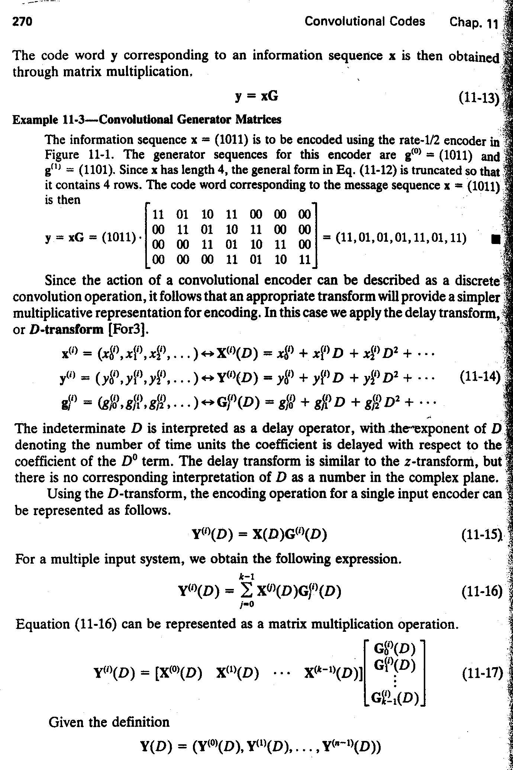

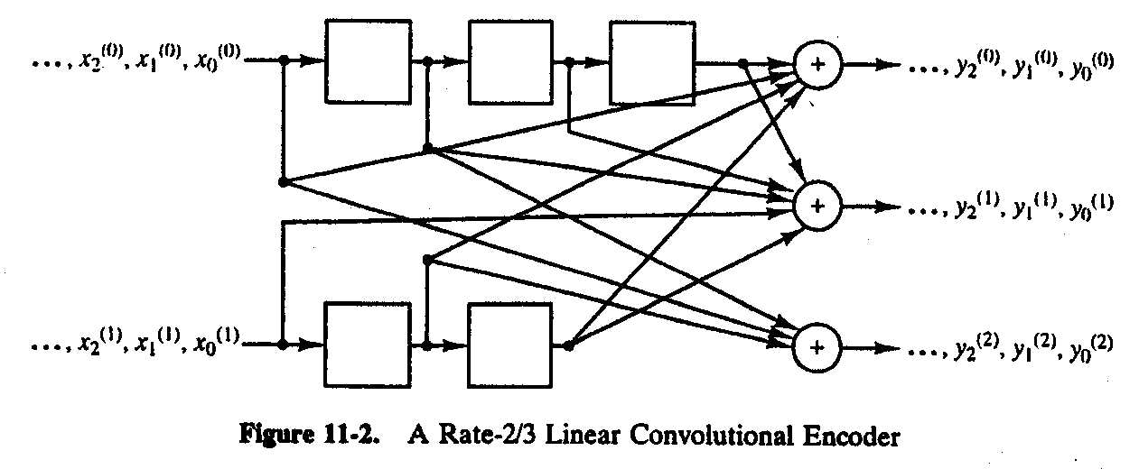

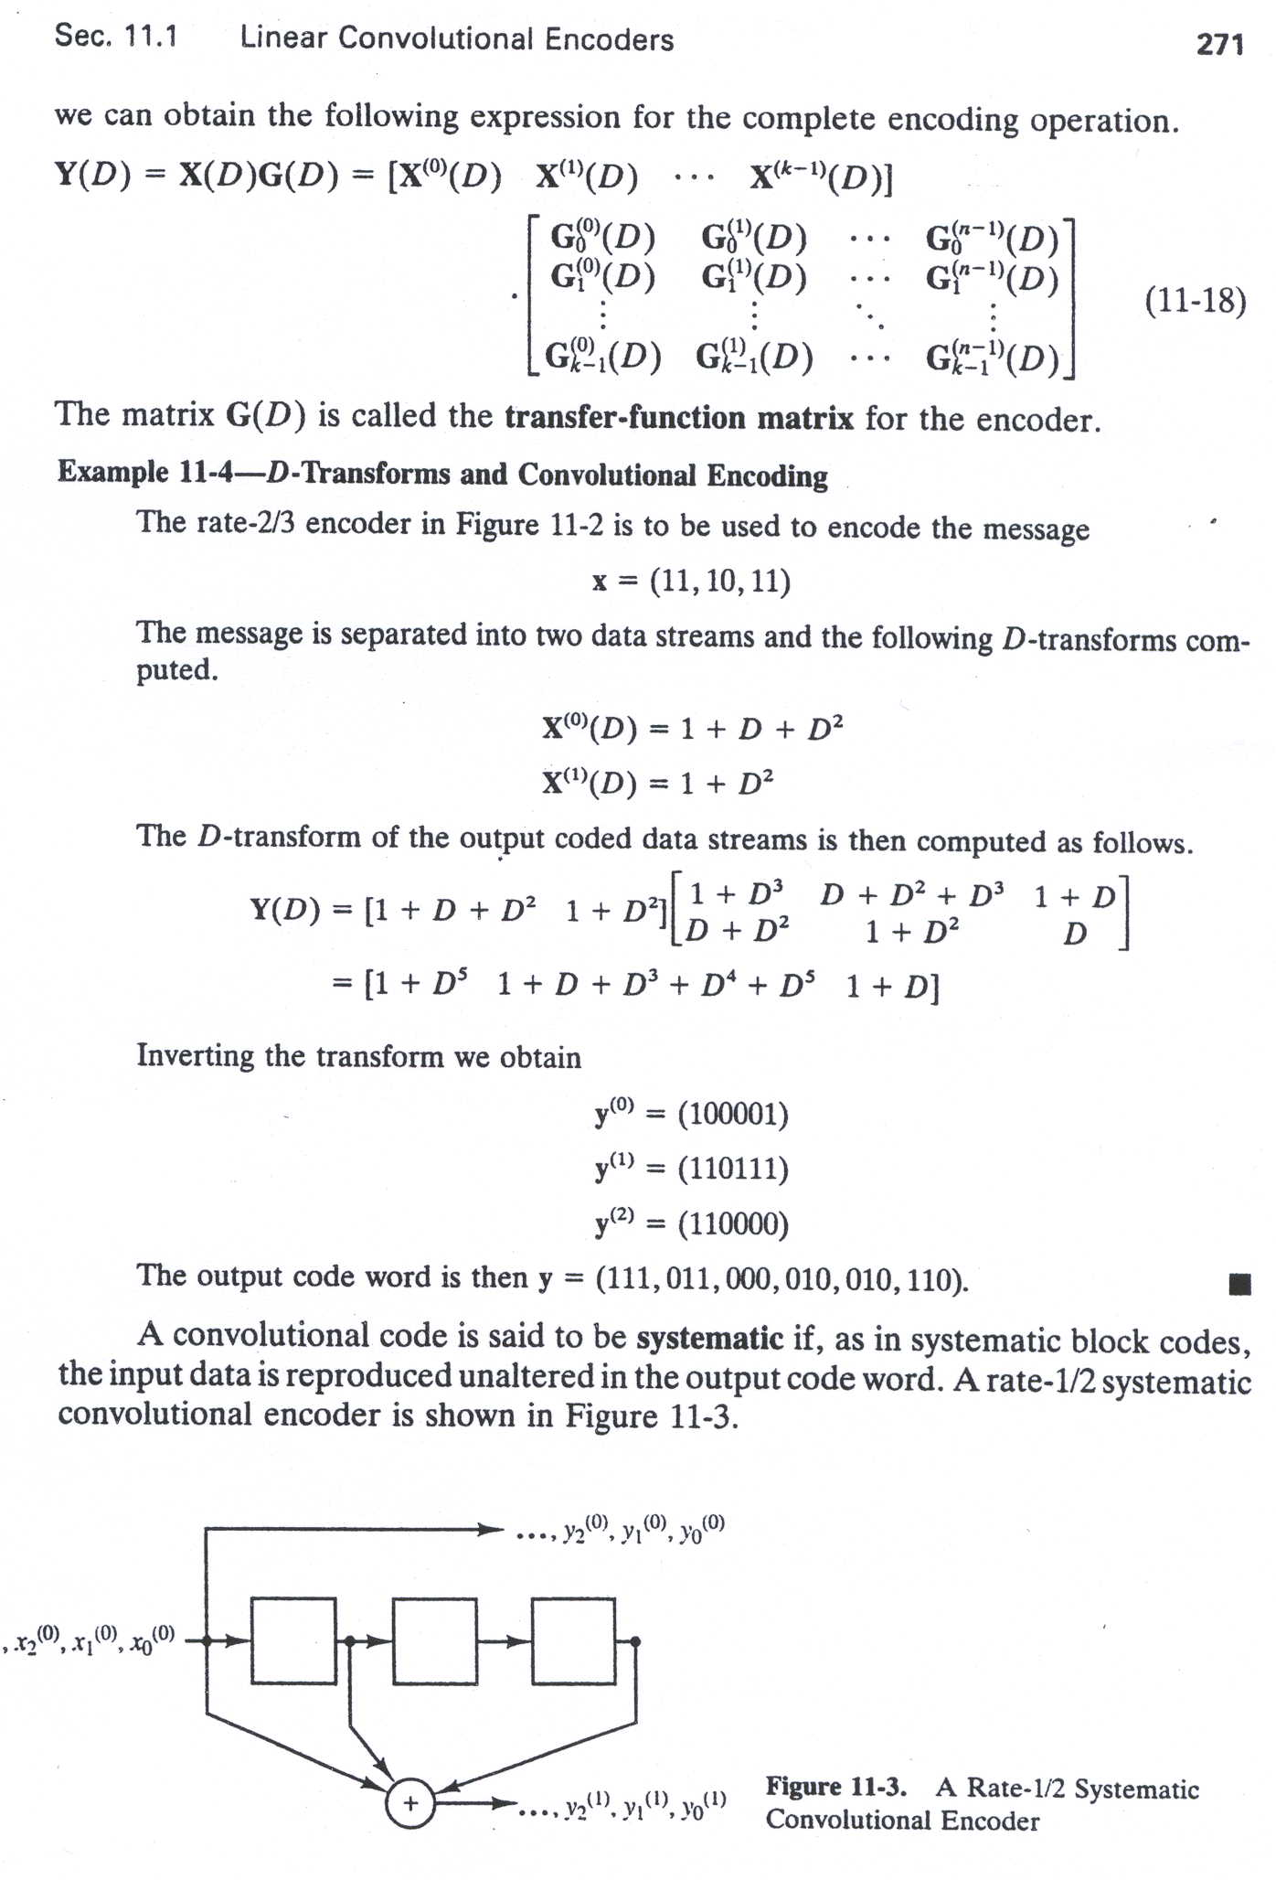

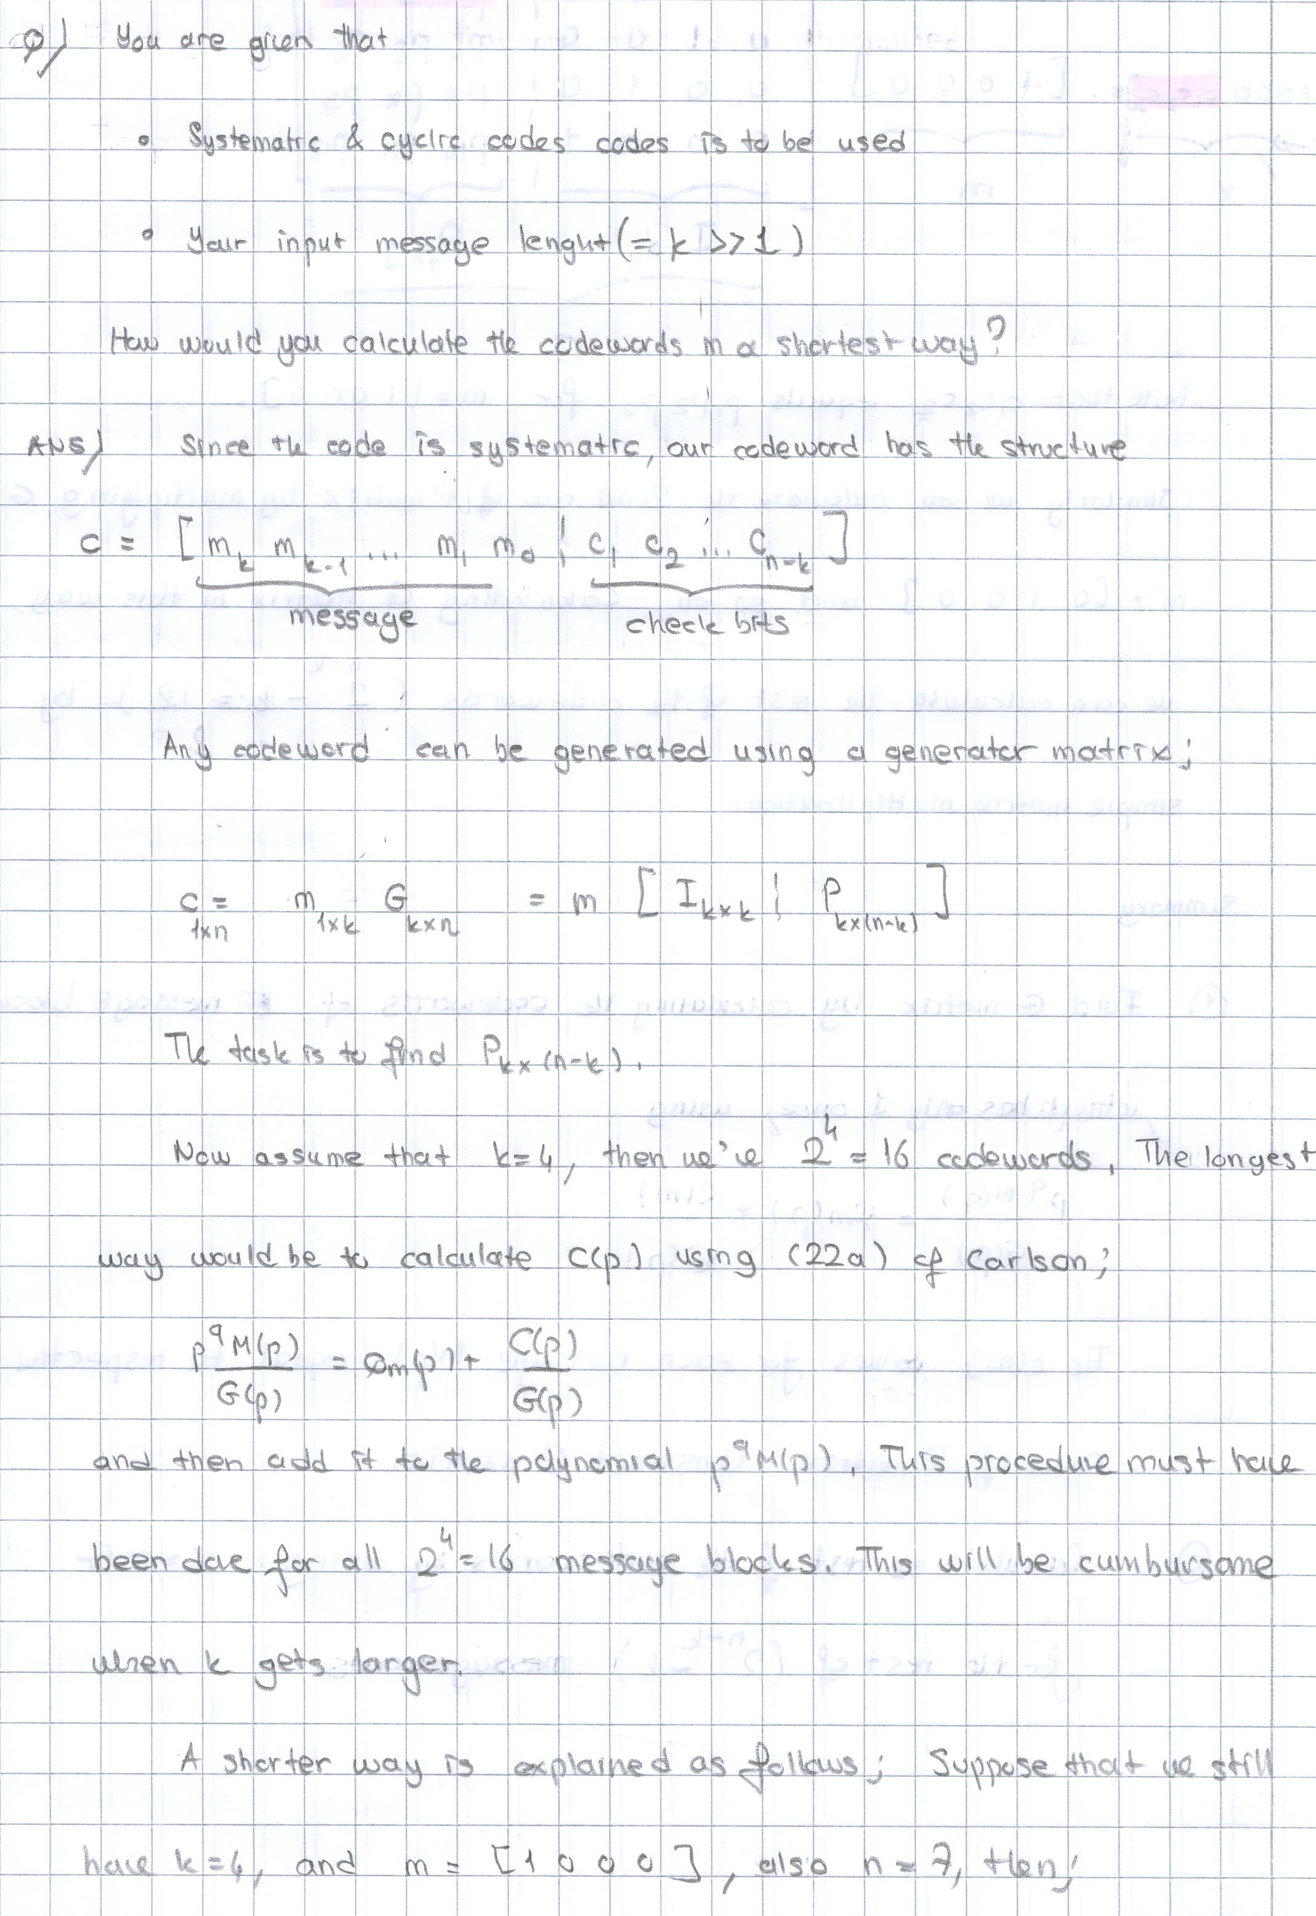

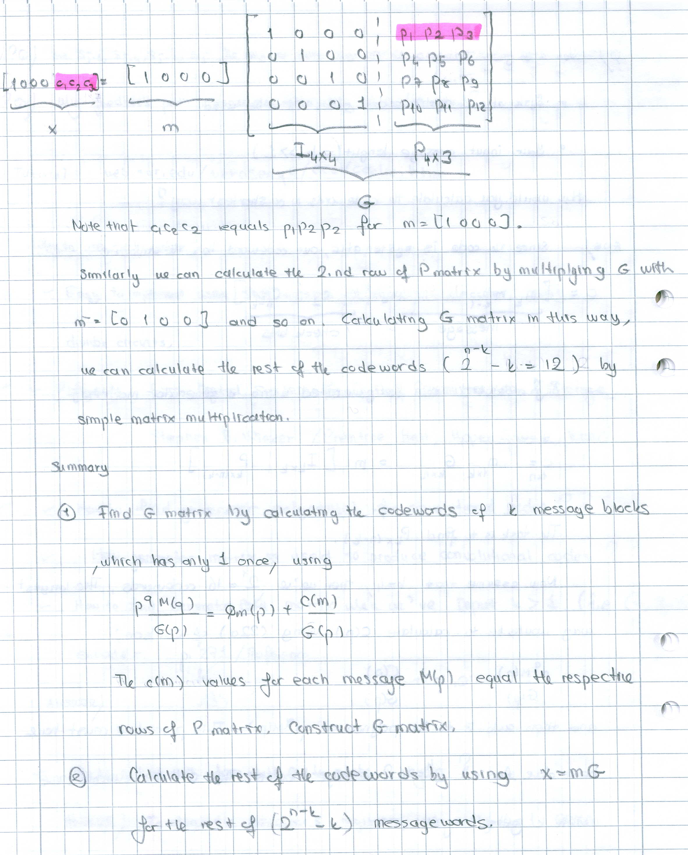

5. How can find a generator polynomial for cycling codes?

The generator polynomial can be any factor of $p^{n}+1$ .In our case we have to consider the fact that we are dealing binary information – we have two levels “0” and “1”.It makes the method ,to put $p^{n}+1$ into factors very complicated Mathematical method exist and it can be found in the reference material[1].

6. How generator matrix is used to produce convolution codes?

Each scheme that implements convolution code can be expressed in matrix form.
For that purpose we need to find impulse response of the coder .An impulse response is obtained for the i.th output of an encoder by applying a single 1 at the j.th input followed by a string of zeros. Strings of zeroes are applied to all other inputs. The impulse responses of the encoder in Figure 11.2 has the following impulse response,

$g^{0_{0}}=(\text{1001})$$g^{1_{0}}=(\text{0111})$$g^{2_{0}}=(\text{1100})$
$g^{0_{1}}=(\text{0110})$$g^{1_{1}}=(\text{1010})$$g_{1^{2}}=(\text{0100})$

where upper index denotes the output and lower index denotes the input.
The impulse responses are often referred to as generator sequences, because their relationship to the code words generated by the corresponding convolutional encoder is similar to that between generator polynomial and code words in a cyclic code .The generator sequences have been terminated at the point beyond which all of the output stream contain nothing but zero. Message bits and impulse response bits can be presented as polynomials. And after that they can be mapped into a matrix. Matrix multiplication will perform convolution between message and generator bits and as a result the desired signal will be produced.

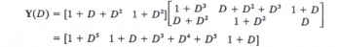

7. Explain state transition in decoding scheme.

The encoder (figure 11.2) has three memory cells so eight different states. Each brunch in the state diagram has a label of the form X/YY , where X is the input bit that cause the state transition and YY is the corresponding pair of output bits. Example: For that encoder we have next states:

S0 =(000) S4=(001) S1=(100) S5=(101) S2=(010) S6=(011) S3=(110) S7=(111)

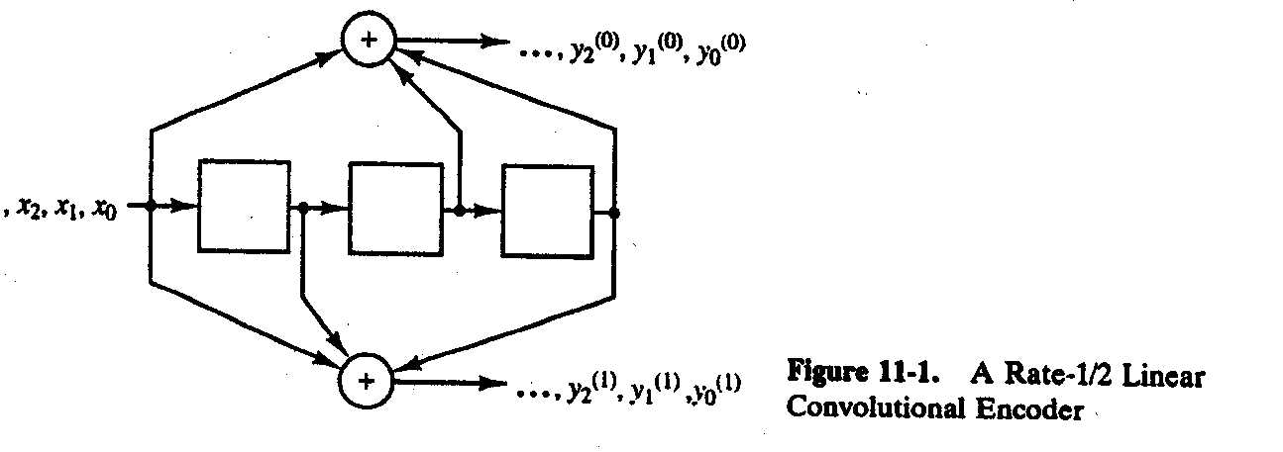
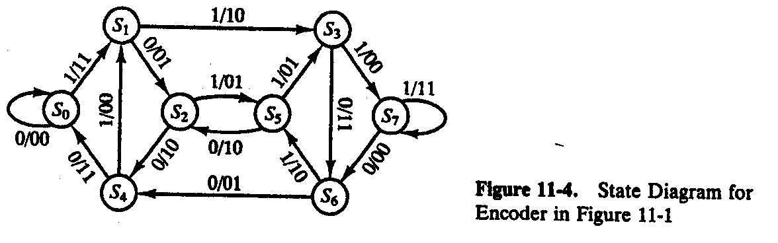

Assume that we are in state S3.It means that in the first memory element we have 1, in second 1 and in third 0.Then we apply 1 to the input. First we calculate what we receive in each output, without making any transition. On the first output we receive 0, as in the second one. So the label we have is in the form X/YY = 1/00.Now we shift the information in the sells and the new state is 111 - in each memory cell now we have 1.It correspond to state S7. With that transition we move from state S3 to state S7.In the same way we can label all brunches of the state diagram.

8. Why when coding and decoding we have to finished in state S0 – all bits zero?

After convolution we have to left the register in state “all zero” so to be sure that even the last bit from the word is convolved with all symbols from the matrix. After that in the registers we will have only zeroes that corresponds to state S0.

Reference:

1. Stephen B. Wicker Error control systems for digital communication and storage.
2. Lecture notes : http://www.comlab.hut.fi/opetus/227/2002/fld.htm
3. For more information on

  - Galois Fields,
  - Common divisors in Cyclic codes
  - How to find the generator polynomial in cyclic codes

S.B.Wicker, Error Control Systems for Digital Communication and Storage, Prentice Hall, Upper Saddle River, NJ, 1995.

