S-72.227 Digital Communication Systems Lecture 3

Discussion Agent Group
Manuel Enrique Ramírez Montalvo
Daniele Fabio Fuccio

The Viterbi algorithm, coherent bandpass modulation

- Example of using Viterbi algorithm, survivor path.

We have to draw the code trellis tree until the fist L+1 branches (in the example L+1=3 because the convolutional code is a (2,1,2)). In the example we will consider the received sequence Y= 11 01 11. The number in the parentheses beneath each branch is the branch metric, obtained by counting the differences between the encoded bits and the corresponding bits in Y. The circled number at the right-hand end of each branch is the running path metric from a₀.We’ll discard the larger-metric path, marked by an X, and we declare the path with the smaller metric to be the survivor at this node. In this way we’ll leave a total of 2^{kL} =4 surviving paths.

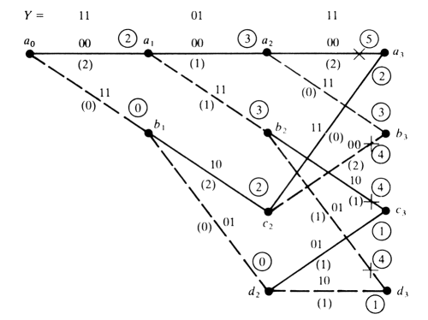

Now we can suppose to have a complete message of N=12 bits
Y= 11 01 11 00 01 10 00 11 11 10 11 00. Now we’ll continue the paths only from the survivors paths and we’ll calculate the complete path metrics. The maximum-likelihood path follows the heavy line from a₀ to a₁₂, and the final value of the path metric signifies at least two transmission errors in Y. The decoder assumes the corresponding transmitted sequence Y+E and the message M written below the trellis.

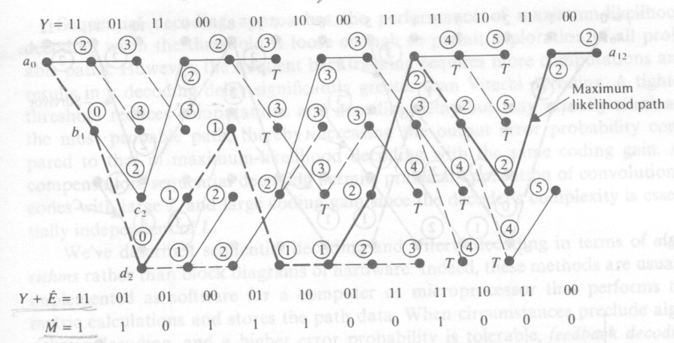

A Viterbi decoder must calculate two metrics for each node and store 2^{kL} surviving paths, each consisting of N branches. Decoding complexity increases exponentially with L and linearly with N. The exponential factor limits practical application of the Viterbi algorithm to codes with small values of L. The storage requirements can be reduced by a truncation process based on the following metric-divergence effect: if two surviving paths emanate from the same node at some point, then the running metric of the less likely path tends to increase more rapidly than the metric of the other survivor within about 5L branches from the common node.

- What is the difference between soft and hard decoding?

Both soft and hard decoding have the same finality, maximize the probability

$$\text{ln}p(y,xm)=\sum_{j=0}^{∞}{\text{ln}p(yj|x\text{mj})}$$

However, soft decoding accounts the decision region energies, and hence the Euclidean metric d^{E}, instead of the Hamming metric d_{free}.
For soft-decoding, the reliability of decision region must be known and several decision region partitions are used.

- What are the two basic ways to realize optimum detection?

The Viterbi algorithm executes maximum-likelihood decoding and achieves optimum performance but requires extensive hardware for computation and storage. The feedback decoding sacrifices performance in exchange for simplified hardware. Sequential decoding approaches optimum performance to a degree that depends upon the decoder’s complexity.

- Discuss a derivation for FSK and/or PSK error rate.

FSK error rate:

To derivate the error rate of FSK, we first consider binary FSK with shift ±f_{d} and signaling waveforms

S₁(t) = A_{c} p_{Tb}(t) cos 2π(f_{c} + f_{d})t
S₀(t) = A_{c} p_{Tb}(t) cos 2π(f_{c} - f_{d})t

When f_{c} ± f_{d} >> r_{b}, E_{b} ≈ A_{c}²T_{b}/2, whereas

E₁₀ = E_{b} sinc (4f_{d}/r_{b})

which depends on the frequency shift. If f_{d} = r_{b}/2, corresponding to Sunde’s FSK, then E₁₀ = 0.

Knowing that

E₁ ∆ $\int{{s1}^{2}(t)\text{dt}}$ E₀ ∆ $\int{{s0}^{2}(t)\text{dt}}$ E₁₀ ∆ $\int{{s0}^{}(t){s0}^{}(t)\text{dt}}$

We can calculate E_{b} = E₁/2 and therefore obtain P_{e} from

$$P_{e}=Q[\sqrt{(E_{b}−E_{\text{10}})/η}]$$

From here we can deduct that the Error probability for FSK is

$$P_{e}=Q(\sqrt{{E_{b}}/η})=Q(\sqrt{γ_{b}})$$

- Compare various coherent schemes with respect of error rate, spectral efficiency and hardware complexity.

On-Off keying (binaryASK) $P_{e}=Q(\sqrt{{E_{b}}/η})=Q(\sqrt{γ_{b}})$
spectral efficiency $r_{b}B_{T}=1\text{bps}/\text{Hz}$

Phase-reversal keying (PRK) $P_{e}=Q(\sqrt{2{E_{b}}/η})=Q(\sqrt{2γ_{b}})$
The constant envelope of PRK makes it relatively invulnerable to nonlinear distortion.
spectral efficiency $r_{b}B_{T}=1\text{bps}/\text{Hz}$

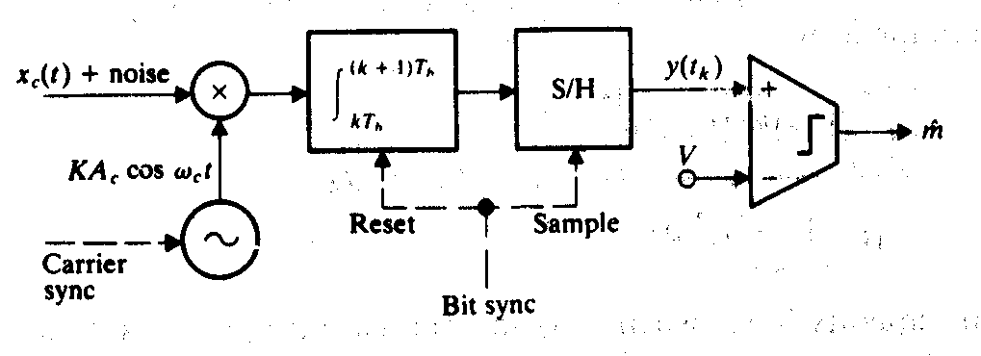

Sunde’s FSK $P_{e}=Q(\sqrt{{E_{b}}/η})=Q(\sqrt{γ_{b}})$

spectral efficiency $r_{b}B_{T}=1\text{bps}/\text{Hz}$
An optimum FSK receiver is more complicated than a correlation receiver for OOK or PRK.

- When to use which modulation method?

To decide which modulation method should be used in a specific system; we need to make considerations of bandwidth, speed of modulation and complexity of the hardware. It is important to remember that for narrower bandwidth, we introduce ISI because of the filters employed to limit the band.
The capacity of the channel and spill over effect should be taken in account, as well as

- What parameters allow us to decide which convolutional coding methods is better and why?

Good convolutional codes must be discovered by computer search and simulation. Two important parameters, to decide which coding method is better, are the coding gain RCdf /2 and the maximum free distance d_{f}. Observe that the free distance and coding gain increase, with increasing memory of length L, when the code rate R_{c} is held fixed. The listed codes in the table are nonsystematic; a systematic convolutional code has a smaller d_{f} than an optimum nonsystematic code with the same rate. The free distance serves as a measure of the error-control power and the coding gain is important because convolutional coding improves reliability when R_{c}d_{f} /2 > 1 under the assumption of gaussian noise.

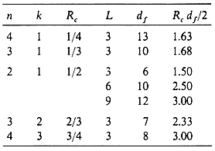

- Why is the Viterbi algorithm so powerful in decoding convolutional codes?

Maximum-likelihood decoder must examine an entire received sequence ‘Y’ and find a valid path that has the smallest Hamming distance. There are 2^{N} possible paths for any arbitrary message sequence of N bits, so an exhaustive comparison of Y with all valid path would be an absurd task in the usual case of N >> 1.The Viterbi algorithm applies maximum-likelihood principles to limit the comparison to 2^{kL} surviving paths independent of N, thereby, bringing maximum-likelihood decoding into the realm of feasibility.
A Viterbi decoder must calculate two metrics for each node and store 2^{kL} surviving paths, each consisting of N branches. Decoding complexity increases exponentially with L and linearly with N. The exponential factor limits the practical application of the Viterbi algorithm to codes with small values of L. The storage requirements can be reduced by a truncation process based on the following metric-divergence effect: if two surviving paths emanate from the same node at some point, then the running metric of the less likely path tends to increase more rapidly than the metric of the other survivor within about 5L branches from the common node.

- What modulation condition should be true in order to have an easy spectral analysis of x_{c}(t)?

Spectral analysis of x_{c}(t) is relatively easy when the i and q components are statistically independent signals.

- What is the spillover and how can we prevent it?

It is the spectral component outside the B_{T} bandwidth of the power spectrum. It becomes an important concern in radio transmission and frequency-division multiplexing systems when it creates interference with other signal channels. Bandpass filtering at the output of the modulator controls the spillover, but heavy filtering introduces ISI in the modulated signal and should be avoided. An example in which spectral efficiency is achieved without spillover is the vestigial-sideband modulator.

- How can we define QAM in terms of PRK (Phase Reversal Keying)?

QAM can be though of as two PRK signals on quadrature carriers. This is due to the fact that the binary words for adjacent signal points differ by just one bit. Two examples of PSK signal constellations are shown in the following figure:

0
q
i
(01)
(10)
(00)
(11)

The PSK signal with M = 4 and N = 0 represented in the left figure is designated quaternary or quadriphase PSK (QPSK). If we had taken QPSK with N=1, the signal points would have been identical to binary QAM:

q
i
0
(01)
(10)
(00)
(11)

- What are the two basic methods for digital frequency modulation?

The two basic methods for Frequency modulation are Frequency-shift keying (FSK), represented by the following diagram:

…
x(t)
xc(t)

Where the digital signal x(t) controls a switch that selects the modulated frequency from a bank of M oscillators. The modulated signal is therefore discontinuous at every switching instant t = kD unless the amplitude, frequency and phase of each oscillator has been carefully adjusted.

The discontinuity is avoided in continuous-phase FSK (CPFSK) represented in the following figure:

x(t)
xc(t)
Frequency
modulator

Where x(t) modulates the frequency of a single oscillator. Both forms of digital frequency modulation pose significant difficulties for spectral analysis.

- How does CPFSK assures phase continuity for all t?

Analyzing

$$x_{c}(t)=A_{c}\sum_{k=0}^{∞}{\text{cos}[}ω_{c}t+θ+φ_{k}+ω_{d}+a_{k}(t−\text{kD})]p_{D}(t−\text{kD})$$

Where

$$φ_{k}≡ω_{d}D\sum_{j=0}^{k−1}{a_{j}}$$

We can see that CPSK has a frequency shift f_{d}a_{k} in the interval kD < t < (k + 1)D, just like FSK. Bu it also has a phase shift φ_{k} that depends on the previous digits. This phase shift results from the frequency-modulation process and ensures phase continuity for all t.

- What are the advantages of MSK (fast FSK)?

MSK is a binary CPFSK with $f_{d}=r_{b}/4$ so the frequency spacing is half that of Sunde’s FSK. This, together with the continuous phase property, results in a more compact spectrum free of impulses (see binary FSK). In the plot we can observe that G_{c}(f) has minuscule spillover beyond the central lobe of width 3r_{b}/2 and for this reason we can take ${r_{b}}/{B_{T}}≈2{\text{bps}}/{\text{Hz}}$ we can see here that we have twice the modulation speed of Sunde’s FSK and this is the reason why we call this modulation fast FSK.

- What is the analog system that can be compared to coherent binary systems?

Coherent bandpass digital systems employ information about the carrier frequency and phase at the receiver to detect the message – like synchronous analog detection.

- Describe two alternatives to a bandpass filter matched to the difference between the two signaling waveforms in optimum binary detection.

One method is to use two parallel matched filters as shown in the figure (a). After subtracting the output of the lower branch from the upper branch we get the same optimum response. Another alternative is based on the following observation:
The sampled signal value from the upper branch in figure (a) is

$z_{m1}(t_{k})=\int{s_{m}(t−{\text{kT}}_{b})}\text{Ks}(t−{\text{kT}}_{b})\text{dt}$

and likewise for z_{m0}(t_{k}). Hence, optimum filtering can be implemented using the system in figure (b), in which we require two multipliers, two integrators and stored copies of s₀(t) and s₁(t). The last system is called correlation detector because it correlates the received signal plus noise with noise free copies of the signaling waveforms.

