DISCUSSION AGENT GROUP NOTES - Spread Spectrum Systems II
BY: Hakan Cuzdan, 55984M

This material follows the study guide 10’s important topics, which are colored blue.

WCDMA basics: FDD vs. TDD, spectrum allocation, spreading, permitted spreading factors / channel bit rates

Q1) What are the prons and cons of UTRAN-TDD over UTRAN-FDD
Answer)

Pros:
- In TDD, uplink & downlink signals are separated in time using the same spectrum. This enables us to reserve more time (more capacity) to DL
- To have ease of channel estimation and no need for duplex filtering.

Cons:
- However, TDD is needs synchronization requiring more complexity

Q2) What are the permitted spreading factors in uplink/downlink WCDMA?
Answer) Uplink: DPCCH SF = 256 (control channel, quadrature branch)
DPDCH SF = 4 – 256 (Data channel, in phase branch)

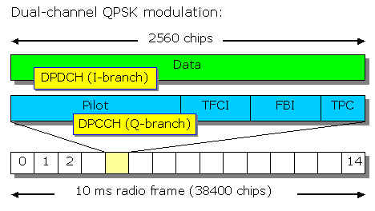
Figure 1

Downlink: SF = 4-512
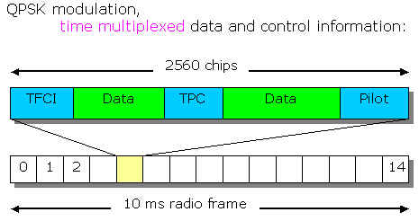

Figure 2

Q3) Why user data rate is less than channel bit rate in WCDMA?
Answer) Because, user data is coded & rate matched to obtain channel data increasing bit rate. Therefore, effective user data rate is less than the channel bit rate transmitted.

WCDMA channel concept and channel mapping (logical / transport / physical channels)

Q4) What are different logical channels are used in WCDMA and what is their relation with the radio interface?
Answer)
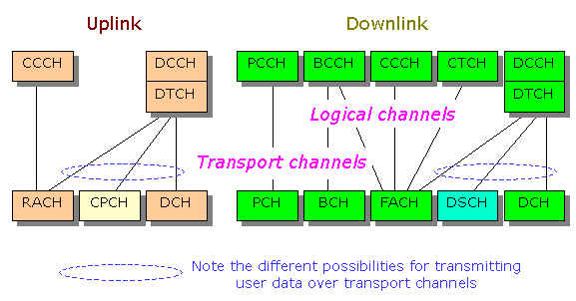
Figure 3

Logical channels are used for data & control information transmission. They are separate for uplink & downlink transmission. Each logical channel is mapped to a transport channel, which is transmitted in either in-phase or quadrature channels. Below given an example for uplink data & control transport channels.

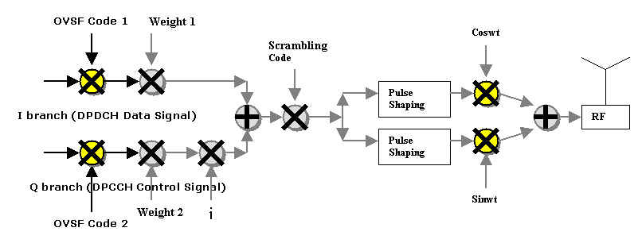
Figure 3a

Below given an example for downlink data & control transport channels:

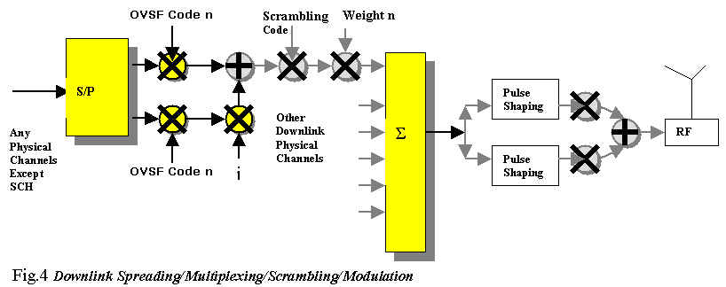

Chip sequence processing at transmitter (spreading, scrambling, multiplexing, modulation

Q5) Describe the Uplink Spreading/Multiplexing/Scrambling/Modulation process in WCDMA?

Answer) 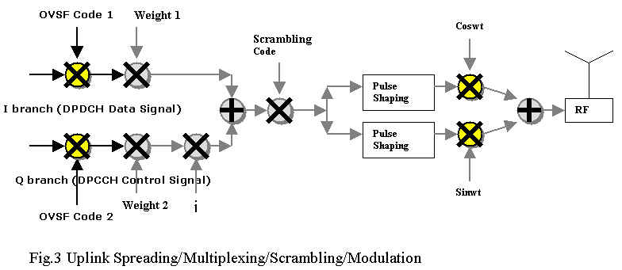

Note that logical channels are directly interrelated with spreading because they use different branches & different channelization codes (OVSF 1,2). So, at the receiver side, they are separated in code domain at the baseband. As noted before, Q-Branch has fixed rates whereas I branch can have varying rates via the use of TFCI (refer to Fig.1). Note that the signal formats and processing is standardized at transmitter site. This is because we have to receive standardized signals to process at the base station. After using scrambling code to identify the mobile at the receiver side, pulse shaping & QAM modulation takes place.

Q6) Describe the Downlink Spreading/Multiplexing/Scrambling/Modulation process in WCDMA?

Answer)

In Downlink, the different users are separated by different channelization codes (OVSF code n) and different BSs are identified by different set of scrambling codes. Multiplexing is done at the baseband level by simply adding the signals for different MS’s. Note that the power updates of different mobiles are done via multiplication of weights. Also, as noted earlier in Fig.2, I & Q branches uses the same channalization code to transmit the same type of information in two parallel data streams.

Q7) Soft handover: why and how?

Macro diversity is a term used to indicate that different de-spread signals coming from several BSs are combined/selected at the serving RNC or MS. Micro diversity refers to Rake Reception at either BS or MS. Soft handover refers to using either more than one BS at uplink or downlink.

In uplink, the SRNC selects the best of the signal from / demodulated / despreaded /decoded coming from different BSs. It uses majority voting technique or BER quality metric. This helps to reduce the interference level, if the MS follows the power update commands from the best MS, which requires the least power.

In downlink, several BSs sends signals using different scrambling codes identifying them. The BS has the set of different scrambling codes corresponding to different BS, so it is able to differentiate the signals from them. After differentiation, the signals are either combined or the best of them in terms of some quality measure is selected. This helps to reduce;

- The handover dropping probability, since the MS is able to catch possibly strong signals from one of BSs
- The received signal quality

The handicaps of soft handoff in downlink are;

- Reduced capacity due to increased interference & each BS’s limited capability to handle a given number of MSs.
- Increased complexity at MS’s equipment.

Q8) Considering Rake Reception and soft handover in downlink, which code sequence is used at the Rake receiver at the MS to despread the signal coming from a specific BS?

Answer) We know that there are 2 types of codes used in downlink. The channelization code is used for MS seperation and the scrambling codes are for BS seperation in the downlink. Regarding the downlink soft-handover in WCDMA & rake reception, the combined code (channelization + scrambling code) is used to despread the signal coming from a specific BS.

Q9) Power control: why and how?
Answer) The main reason why power control is needed is near far problem. It happens when a powerful signal coming from a near MS suppresses the weaker signal from a distant MS. This is because; the powerful signal causes an increase in interference, decreasing the SIR of distant user. If the SIR goes below a threshold, the BS cannot receive the signal from the distant user with a required quality and the connection is lost.

To prevent this, WCDMA uses power updates at each time slots of radio frame. TPC bit is used both in uplink and downlink (refer to fig.1&2) to update the power up & down 1500 times per second.

This requires “inner loop power control” where UE increases/decreases its power based on BS commands.

But, at the beginning of a very short connection, such as random access, the MS guesses the power required from downlink reception, which is not very effective since channels are not reciprocal in UTRA-FDD.

Outer loop power control is the case, where the target SIR is changed by RNC according to received data quality (i.e. BER). It periodically updates the SIR target of inner loop. In that respect, Outer & inner power controls work together in WCDMA system to combat near & far effect.
Synchronous / non synchronous chip sequences & their usage
Q9) What are the properties of a good spreading code?
ANSWER)
- High autocorrolation value at peak the main lobe which is decaying fast
- Low crosscorrolation between other spreading codewords

Q10) Why do scrambling codes use non-synchronous sequences? And why do Channelization codes use synchronous sequences?

Answer)

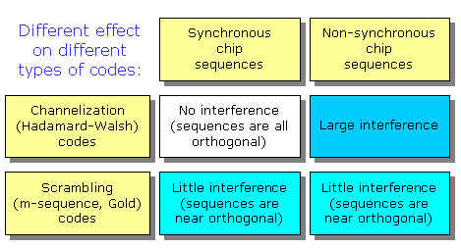

ANSWER) The reason why scrambling codes use non-synchronous sequences is as follows. In uplink, scrambling codes are used to identify the MS, and each MS has different distances from BS. Since synchronization among MS at BS is costly, it is desired to have small crosscorrolation between asynchronously received different scrambling codes. In downlink, scrambling codes are used to identify the different BSs, whose signals arrive asynchronously at the mobile. Again, it is required to have minimum cross correlation between different sequences.

Channelization codes use synchronous sequences because when aligned, they give zero crosscorrolation. In downlink, when since BSs’ signals is aligned at the BS before transmission, they give good user separation results at the MSs.

