S-72.245 Transmission methods in Telecommunication Systems
Tutorial 2

Objectives
- Get familiar with transmission channel basic properties
- Study impairments of transmission channels
- Study modeling of linear channels

Quizzes
Q1. Define by your own words and give an analytical expression for: Signal power, signal energy, and channel capacity in AWGN channels.

Q1. Briefly explain by your own words the following concepts: Attenuation, distortion, interference, and noise in data communications.

Q2. Study the concept of Group Delay as presented in Annex I. Then explain it by your own words. Can Group Delay equal phase delay - Why or why not?

Q3. a) Compare the properties of guided media and unguided media by calculating attenuation [dB] of omni-directional antenna with n(f) = 2.5, coaxial cable with the attenuation of 2.4 dB/100 m and optical fiber with attenuation of 0.35 dB/km at the propagation distance of 5 km. b) Select two examples of guided media and unguided media and compare their properties by giving pros and cons in some selected applications (pick the applications by yourself).

Q4. Study the concept of coherence bandwidth as presented in Annex II and in the supplied example 4.4. Explain by your own words what it means. Discuss coherence bandwidth in wide band and in narrow band channels by using some formulas.

Q5. Consider matching of a communication channel with to the source of having impedance . Describe goodness of matching as a function of frequency. Is there a frequency where matching is optimized?

M1: Signal x(t) has the duration of 10 seconds and it is defined by
$x(t)=\begin{aligned}\left\{\text{cos}(2π×\text{47}t)+\text{cos}(2π∗\text{219}t),\begin{matrix} & 0≤t≤\text{10}\end{matrix} | \right.\end{aligned}$.
This signal is sampled at the sampling rate of 1000 samples per second. Find the total average power of this signal and find power-spectral density for this signal.

M2: Consider a linear transmission channel that is defined by the transfer function
a) Plot its phase and frequency response up to 10 Hz based on this given expression. What is the 3 dB frequency bandwidth of the channel?
b) Create a Matlab program to estimate channel frequency response by feeding white noise to its input.
---------------------------------------------

Annex I (See also Carlson's IV ed, pp. 91-94)

Annex II
Ref: www.williamstallings.com

Ref : T.S. Rappaport: Wireless Communications
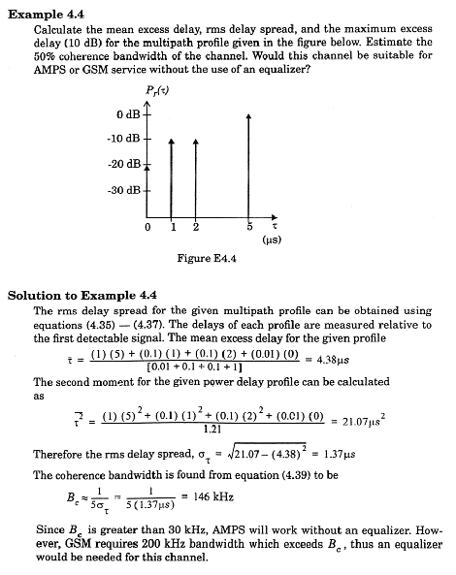

Ref : T.S. Rappaport: Wireless Communications

