S-72.245 Transmission Methods in Telecommunication Systems
Tutorial 5

Objectives

- To investigate and model analog CW communications with AWGN noise
- Getting familiar with analytical presentations of linear and exponential CW modulation in noisy channels.
- Understanding some of the respective detection principles

Quizzes

Q5.1 Collect from lecture handouts quadrature lowpass expressions of bandpass channel noise in polar and rectangular form and the expressions for the pre-detection and post-detection SNR for DSB and FM.

Q5.1 Express received (pre-detection) SNR for FM in case of narrowband modulation in terms of , and compare it to the respective expression of wideband FM modulation. What are your conclusions?

Q5.2 Prove the definitions of mean and variance of bandpass noise envelope and by starting from the definition of Rayleigh distributed PDF of the noise envelope.

Q5.3 A communication system has the average modulating signal power of , message bandwidth , channel noise power spectral density of and the transmission loss of L = 10 dB. Determine the average received signal power required to get post detection SNR = 40 dB when the modulation is (a) SSB and (b) AM with the modulation indexes , and .

Q5.4 Signal is sent via FM without preemphasis. Calculate when and the post-detection filter is an ideal BPF passing frequencies in the range of .

Error: Reference source not found

Matlab assignments

M5.1 Generate a set of random numbers (set_size = {10^{n},n = 1 ... 6}) by using two independent, zero mean Gaussian random variables with and to experimentally investigate the expression . Plot your result in a diagram showing simulated variances as a function of set_size. Comment your plot!

M5.2 Periodic message m(t) with the period is defined by
This message DSB modulates the carrier,, resulting the signal u_{DSB}(t). Plot the modulated signal with (SNR = 10 dB) and without additive noise.

M5.3 Figures below show waveforms encountered in a zero-crossing FM-detector that is based on estimating instantaneous frequency changes of the carrier by calculating number of carrier voltage zero crossing in a time unit.

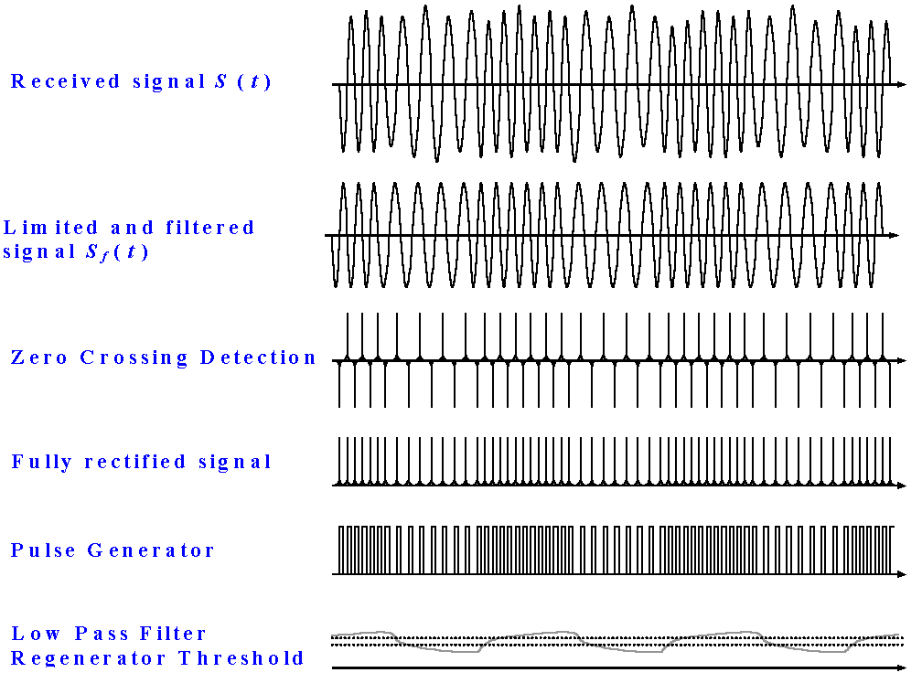

Assume that the message is a periodic signal with the period of T = 2 sec described by
that frequency modulates a 1000 Hz carrier with the modulation constant of and that the signal is applied then to an AWGN channel. Frequency demodulate the signal by using the zero-crossing detector and plot the FM-signal and the message signal before and after detector when the ratio of noise power to the modulated signal power is 0.05.

References
- A. Bruce Carlson: Communication Systems IV ed, chapter 9 and chapter 10
- B. P. Lahti: Modern Digital and Analog Communication Systems third ed, chapter 12

