802.11b/ISM PHY
(Spring 2004)
Mohammad Abualreesh, mohammad.abualreesh@hut.fi
Helsinki University of Technology
Abstract—This paper presents the IEEE802.11b physical layer in the 2.4GHz ISM band according to IEEE standards. This includes the main principles, essential features and characteristics, available modulation schemes and rates, and the various physical framing formats. Hence, in particular, FH SS PHY and DSSS PHY which are known as the low rate PHYs (1Mbps and 2Mbps) and HR DSSS PHY which is known as the high rate PHY (5.5Mbps and 11Mbps).
Region

Index Term — WLAN, FH SS, DSSS, HR DSSS, CCK.

INTRODUCTION
THE world is going wireless. After introduction of the IEEE802.11b which is known as WLAN, these wireless networks provide a comparable performance as that for normal Ethernet However, more features are achieved in WLANs; especially the seamless connectivity, the flexibility, and the mobility. With WLANs, applications such as Internet access, e- mail and file sharing can now be done in the home or office environments with new levels of freedom and flexibility. It is predicted that there are going to be nearly 20 million WLAN systems installed in 2004.
In 1997, IEEE introduced three implementations for PHY (Physical) layer:
- Infrared (IR): IR is a modulation technique where data is sent with infrared light (wavelength 850nm-950nm) and requires line of sight. This technique is intended for indoor use.
- Radio Frequency (RF) - Frequency Hopping Spread Spectrum (FHSS): with low rates 1Mbps and 2Mbps.
- Radio Frequency (RF) - Direct Sequence Spread Spectrum (DSSS): with low rates 1Mbps and 2Mbps.
Later, in 1999, new technique introduced which is known as High Rate Direct Sequence Spread Spectrum (HR DSSS) to provide higher rates of 5.5Mbps and 11Mbps.
IEEE802.11b operates in the 2.4GHz Industrial, Scientific, and Medical (ISM) band which is poised for strong growth. The ISM band is illustrated in Figure1 over the world regions. It is clear that the 2.4GHz is common between all of the world regions.
Figure1 the ISM band.

IEEE802.11

Reference model
IEEE802.11b PHY concerns with the lower layer in the OSI model as depicted in Figure2.
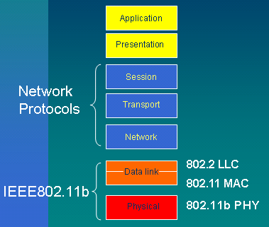
Figure2. IEEE802.11b – OSI model

CSMA/CA
IEEE 802.11 uses Carrier Sense Multiple Access with Collision Avoidance (CSMA/CA) to access medium. Wherein, if a station wants to transmit, it first senses the medium. If the medium is busy, the state defers its transmission to a later time. Otherwise, it is allowed to use the medium. Because of the Hidden Node Problem (two different nodes try to access the same destination node simultaneously), collision could occur. However, to avoid collisions, a RTS/CTS mechanism is implemented. When a station gets the chance to send, it sends a short message first. This message is called Ready To Send (RTS). The destination returns a Clear To Send (CTS) message. After that, the source station can begin to send the data. Since collisions may not be detected by source station, the destinations will ACK every packet.

Spreading Techniques
IEEE802.11b utilizes spreading techniques: FHSS and DSSS techniques. However, the latest IEEE802.11b utilizes DSSS for high rates which is known as HR DSSS. Spreading techniques have a lot of advantages to be used in WLANs such as:
- Immunity from Noise and interference
- Immunity from multipath distortion
- Immunity from freq selective channel fading
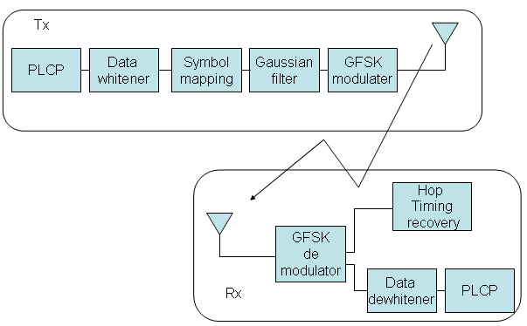
Figure5 FHSS transceiver
- Also can be used for encrypting signals (only the recipient knowing the spreading code can recover the encoded information)
- Several user can independently use the same higher bandwidth with very little interference
In the following sections we will look at FHSS, DSSS, and HR DSSS techniques in more details.

IEEE802.11b PHY FHSS
Frequency hopping depends on rapidly changing the transmission frequency in a predetermined pseudorandom pattern.Figure3 shows the frequency hopping principle. In FH, each frequency is used for a small amount of time, called dwell time. If two FH systems need to share the same band, they can be configured with different hopping sequence so they do not interfere as illustrated in Figure4. In FHSS the ISM band into a series of 1-MHz channels, as shown in Table1 where the dwell time is 390 time units or 0.4 seconds. Each regulatory sets its own hopping sequence based on 802.11 specifications as shown in Table2. FHSS is effective against large narrow band interference.
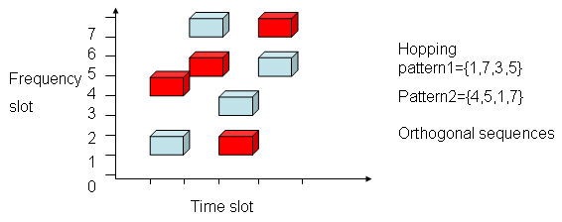
Figure4 Orthogonal Frequency hopping sequences
FH utilizes GFSK (Gaussian Frequency Shift Keying) modulation scheme: both 2GFSK for 1Mbps, and 4GFSK for 2Mbps. In GFSK data is encoded as a series of frequency changes in a carrier and the shape of the radio pulses are Gaussian shapes. A general FHSS transceiver is shown in Figure5.

IEEE802.11b PHY DSSS
In DSSS, each bit in original signal is represented by multiple bits in the transmitted signal. Spreading code spreads signal across a wider frequency band where spread is in direct proportion to number of bits used. This idea is illustrated in Figure6. Spreading uses a 11chip Barker code: [+1,-1,+1,+1,-1,+1,+1,+1,-1,-1.-1] with nearly impulsive autocorrelation.
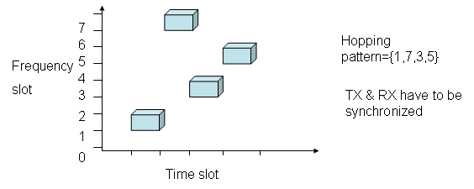
Figure3 Frequency hopping

DSSS is effective against moderate interference levels. In DSSS the symbol rate is 1MHz and the chip rate is rate of code sequence 11 MHz, so the processing gain= Symbol rate/Chip rate=10 dB. The allowed channels in DSSS are shown in Table3.
Regulatory | Channel
FCC-US | 2 to 79  (2.402 - 2.479GHz)
IC-Canada | 2 to 79  (2.402 - 2.479GHz)
ETSI-Europe except France & Spain | 2 to 79  (2.402 - 2.479GHz)
France | 48 to 82  (2.448 - 2.482GHz)
Spain | 47 to 73  (2.447 - 2.473GHz)
MIKK-Japan | 73 to 95  (2.473 - 2.495GHz)
Table1 FHSS - channel used in different regulatory domains.
Two modulation schemes are available in DSSS: 1Mbps Differential binary phase shift keying (DBPSK) and 2 Mbps Differential quadrature phase shift keying (DQPSK). A DSSS transceiver is shown in Figure7.

IEEE802.11b phy HR DSSS
In HR DSSS new schemes has been utilized which is the Complimentary Code Keying (CCK). CCK is a variation on M-ary BiOrthogonal Keying (MBOK) modulation where one of the M unique (nearly orthogonal) signal code words is chosen for transmission. CCK uses the complex set of Walsh/Hadamard functions known as Complementary Codes. Useful property of CCK Modulation that it provides protection against phase ambiguity in receiver’s phase-locked loop.
Regulatory | Hop set size
FCC-US | 26
IC-Canada | 26
ETSI-Europe except France & Spain | 26
France | 27
Spain | 35
MIKK-Japan | 23
Table2 FH sequence sets
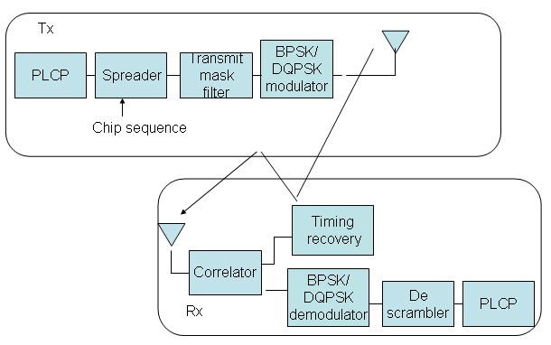
Figure7 DSSS transceiver

In CCK the symbol rate 11/8 = 1.375 MHz where the chip rate 11MHzand there are 8 chips per symbol and the used modulation is the QPSK modulation. However, there are two rates in CCK: 5.5 Mbps 4 bits or 16 codes per symbol and 11 Mbps 8 bits or 256 codes per symbol. The CCK transceiver is shown in Figure8.
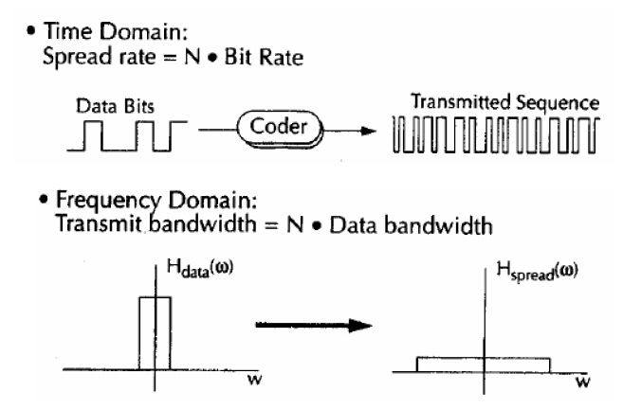
Figure6 DSSS principle
Regulatory | Channel
FCC-US | 1 to 11  (2.412- 2.462GHz)
ETSI-Europe except France & Spain | 1 to 13  (2.412 - 2.472GHz)
France | 10 to 13  (2.457 - 2.472GHz)
Spain | 10 to 11  (2.457 - 2.462GHz)
MIKK-Japan | 14  (2.484GHz)
Table3 DSSS - channel used in different regulatory domains.
Other optional modulation can be used such as PBCK (Packet Binary Convolution Coding) to obtain high rates.

PLCP formats
IEEE802.11b PHY layer consists of two functions:
- Physical layer convergence function; supported by PLCP (Physical Layer Convergence Procedure) that defines method of mapping MAC sublayer Protocol data units MPDU into frame suitable for sending and receiving user data and management information between STAs. Also it enables MAC to operate at minimum dependence on PMD by simplifying PHY service interface to MAC services
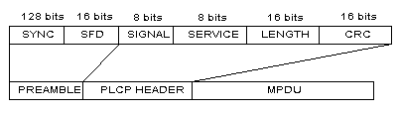
Figure11 DSSS/HRDSSS PLCP format
- PMD (Physical Media Dependent) function that provides methods for transmitting and receiving data through the wireless medium.
A General IEEE802.11 PLCP is shown in Figure9. PLCP frames are composed of the following components: Preamble is PHY dependent. It includes two parts: Synchronization (SYNC) and Start Frame Delimiter (SFD). SYNC is a sequence of scrambled zeros and ones, which is used by the PHY circuitry to select the appropriate antenna, and to reach steady-state demodulation and synchronization of bit clock. SFD is used to define frame timing. The PLCP is transmitted at 1 Mbps and contains logical information used by the PHY layer to decode the frame. PLCP signaling field contains the rate information. The Service field is reserved for future use. The Length field indicates MAC data length or the number of microseconds required to transmit the MAC data.
In FHSS, the PLCP format is shown in Figure10, The Preamble SYNC field is an 80-bit field containing an alternating zero-one pattern, transmitted starting with zero and ending with one. The SFD consists of the 16-bit binary pattern 0000 1100 1011 1101 (transmitted leftmost bit first). The first bit of the SFD follows the last bit of the sync pattern. The PLW (PSDU length word) specifies the number of octets contained in the PSDU. The 4-bit PSF (PLCP Signaling field) defines the transmission rate ranging from 1 Mbps to 4.5 Mbps with 0.5 Mbps increments. The first bit of PSF is reserved for future use.
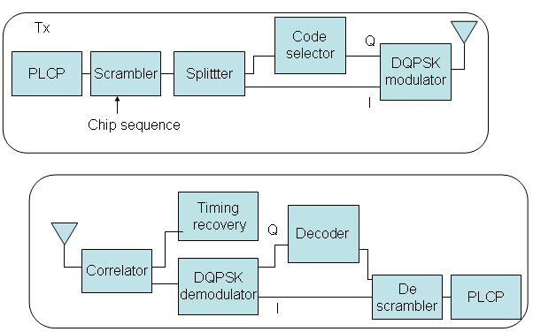
Figure8 HRDSSS transceiver
For DSSS/ HR DSSS, the PLCP format is shown in Figure11. The SYNC field shall consist of 128 bits of scrambled 1 bit. The SFD is a 16-bit '0XF3A0'. The SIGNAL field indicates the data rate:
'0X0A' for 1 Mbps
'0X14' for 2 Mbps
'0X37' for 5.5 Mbps
'0X6E' for 11 Mbps
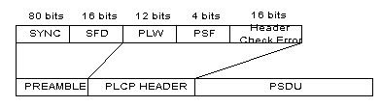
Figure10 FHSS PLCP format

Summary
Here we have discussed IEEE802.11b: FHSS, DSSS, and HR DSSS; and their main features and PLCP formats.
Homework
Explain briefly the main principles and characteristics of CCK (Complementary Code Keying) and the optional PBCK (Packet Binary Convolution Coding) used in IEEE802.11b HRDSSS.
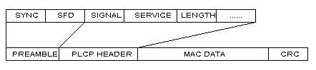
Figure9 General PLCP format
References
- 802.11 Wireless Networks, The definitive guide, Matthew S. Gast, O'Reilly 2002.
- http://eeweb.poly.edu/dgoodman/fainberg.pdf
- In building WLANs http://www.cis.ohio-state.edu/~jain/cis788-99/ftp/wireless_lans/index.html#2.3.1
- A PERFORMANCE ANALYSIS OF THE IEEE 802.11B LOCAL AREA NETWORK IN THE PRESENCE OF BLUETOOTH PERSONAL AREA Networks http://eeweb.poly.edu/dgoodman/fainberg.pdf
- IEEE802.11 standards http://standards.ieee.org/getieee802/portfolio.html

 r

